What is AWS Secrets Manager?
- It is a service that helps you store and protect sensitive information (secrets) like:
  - Database usernames & passwords
  - API keys
  - Tokens
  - Any sensitive configuration data
- It encrypts your secrets automatically and lets you control who can access them.
Step 1: Open AWS Secrets Manager
- Log in to your AWS Management Console.
- In the search bar, type Secrets Manager.
- Click Secrets Manager from the search results.
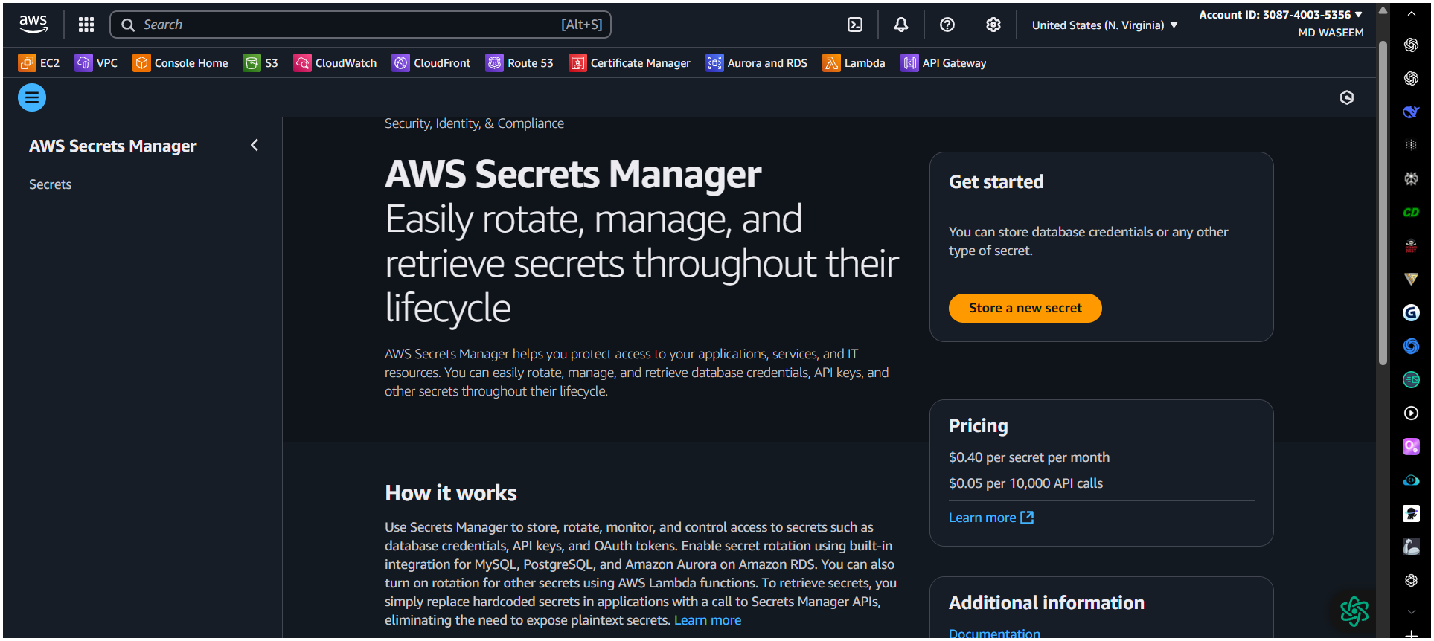

Step 2: Click “Store a New Secret”
- On the main Secrets Manager page, click the Store a new secret button.

Step 3: Choose Secret Type
- Choose what kind of secret you want to store:
  - RDS database credentials – if your secret is for a database.
  - Other type of secrets – for passwords, API keys, tokens, etc.

Step 4: Enter Secret Values
- Add your secret data in key-value pairs:
  - Example:
    - Key: username, Value: admin
    - Key: password, Value: MySecurePass123

Step 5: Select Encryption Key (Optional)
- AWS Secrets Manager automatically encrypts your secret.
- By default, it uses an AWS-managed KMS key (free & automatic).
- If you want more control, you can select your own customer-managed KMS key.

Step 6: Name and Description
- Give your secret a name:
  - Example: prod/db/credentials
- Add an optional description to remember what this secret is for.

Step 7: Configure Rotation (Optional)
- Rotation means automatically changing the secret (like password rotation).
- You can:
  - Turn it off (default).
  - Turn it on and set a time (e.g., every 30 days).
  - AWS can create a Lambda function for you to handle rotation automatically.

Step 8: Review and Store Secret
- Check all your settings.
- Click Store to save the secret.
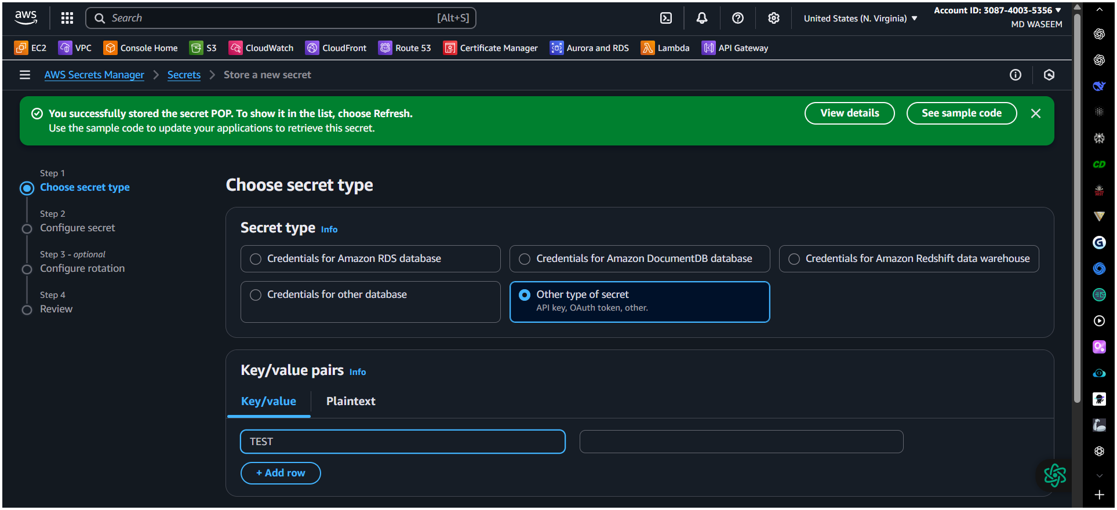
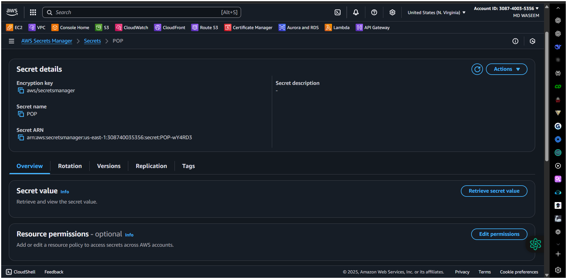

Step 9: Use the Secret
Once created, you can use the secret in multiple ways:
- AWS SDKs (Python boto3, Java, Node.js, etc.)
- AWS CLI
Example:
- aws secretsmanager get-secret-value --secret-id prod/db/credentials
- Other AWS services (RDS, Lambda, ECS, etc.)
- Access control is managed using IAM policies.

Why Use Secrets Manager Instead of Parameter Store?
- Secrets Manager is mainly for credentials & sensitive secrets.
- It supports automatic rotation (Parameter Store does not by default).
- Parameter Store is often used for general configuration values.

